LAB 6
- Unification
Code:
# UNIFICATION ALGORITHM IN PYTHON (Finding Theta)

def is_variable(x):
return isinstance(x, str) and x.islower()

def occurs_check(var, term):
if var == term:
return True
if isinstance(term, list):
return any(occurs_check(var, t) for t in term)
return False

def apply_substitution(theta, term):
if isinstance(term, str):
return theta.get(term, term)
return [apply_substitution(theta, t) for t in term]

def unify(x, y, theta={}):
if theta is None:
return None

if x == y:
return theta

if is_variable(x):
return unify_variable(x, y, theta)

if is_variable(y):
return unify_variable(y, x, theta)

if isinstance(x, list) and isinstance(y, list) and len(x) == len(y):
for xi, yi in zip(x, y):
theta = unify(apply_substitution(theta, xi),
apply_substitution(theta, yi),
theta)
if theta is None:
return None
return theta

return None

def unify_variable(var, x, theta):
if var in theta:
return unify(theta[var], x, theta)

if x in theta:
return unify(var, theta[x], theta)

if occurs_check(var, x):
return None

theta[var] = x
return theta

# -------- INPUT --------
print("\n--- UNIFICATION ALGORITHM ---")

print("\nEnter FIRST expression as a list:")
print("Example: ['P','x','y']")
expr1 = eval(input("Expr1: "))

print("\nEnter SECOND expression as a list:")
print("Example: ['P','a','b']")
expr2 = eval(input("Expr2: "))

# -------- PROCESS --------
theta = unify(expr1, expr2, {})

# -------- OUTPUT --------
if theta:
print("\n✅ Unification Successful!")
print("Theta (θ) = ", theta)
else:
print("\n❌ Unification Failed!")

Output:
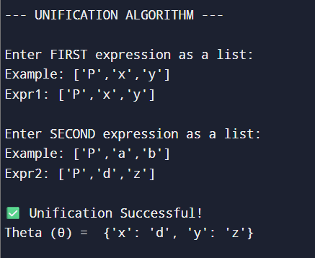

- Alpha beta pruning for tic tac toe
Code:
import math

# Board positions:
# X = AI, O = Human, _ = Empty

board = [
['_', '_', '_'],
['_', '_', '_'],
['_', '_', '_']
]

# Print board
def print_board():
print("\nBoard:")
for row in board:
print(" ".join(row))

# Check win
def check_win(player):
for i in range(3):
if all(board[i][j] == player for j in range(3)): return True
if all(board[j][i] == player for j in range(3)): return True

if all(board[i][i] == player for i in range(3)): return True
if all(board[i][2-i] == player for i in range(3)): return True

return False

# Check draw
def is_draw():
return all(board[i][j] != '_' for i in range(3) for j in range(3))

# Evaluation function
def evaluate():
if check_win('X'): return 10 # AI win
if check_win('O'): return -10 # Human win
return 0

# Alpha-Beta Minimax function
def minimax(depth, isMax, alpha, beta):
score = evaluate()

if score == 10 or score == -10:
return score

if is_draw():
return 0

if isMax: # AI Turn (X)
best = -math.inf
for i in range(3):
for j in range(3):
if board[i][j] == '_':
board[i][j] = 'X'
best = max(best, minimax(depth + 1, False, alpha, beta))
board[i][j] = '_'
alpha = max(alpha, best)
if beta <= alpha:
return best
return best

else: # Human Turn (O)
best = math.inf
for i in range(3):
for j in range(3):
if board[i][j] == '_':
board[i][j] = 'O'
best = min(best, minimax(depth + 1, True, alpha, beta))
board[i][j] = '_'
beta = min(beta, best)
if beta <= alpha:
return best
return best

# Find best move for AI
def best_move():
best_val = -math.inf
move = (-1, -1)

for i in range(3):
for j in range(3):
if board[i][j] == '_':
board[i][j] = 'X'
move_val = minimax(0, False, -math.inf, math.inf)
board[i][j] = '_'

if move_val > best_val:
best_val = move_val
move = (i, j)

return move
# --------- MAIN ---------

# Input some board state
print("Enter current board (use X, O, _):")

for i in range(3):
row = list(input(f"Row {i+1}: ").split())
board[i] = row

print_board()

# AI calculates best move
i, j = best_move()
board[i][j] = 'X'

print("\n✅ Best Move for AI (X):", (i+1, j+1))
print_board()
Output:
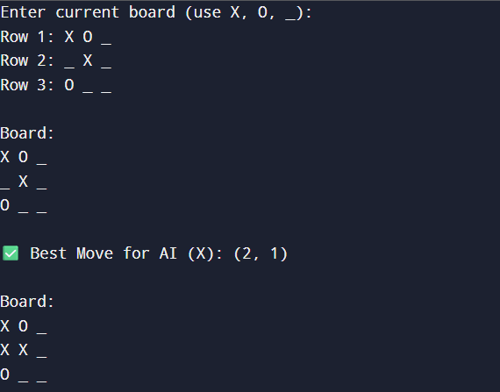
- Alpha beta pruning for 8 puzzle
Code:
import math

GOAL = ((1,2,3),(4,5,6),(7,8,0))
DEPTH_LIMIT = 5 # Limit depth to show pruning

def print_board(state):
for row in state:
print(row)
print()

# Manhattan Distance heuristic
def heuristic(state):
dist = 0
for i in range(3):
for j in range(3):
val = state[i][j]
if val != 0:
goal_x = (val-1) // 3
goal_y = (val-1) % 3
dist += abs(i-goal_x) + abs(j-goal_y)
return dist

# Find empty tile
def find_blank(state):
for i in range(3):
for j in range(3):
if state[i][j] == 0:
return i, j

# Generate moves
def generate_moves(state):
moves = []
x, y = find_blank(state)

directions = [(-1,0),(1,0),(0,-1),(0,1)]

for dx, dy in directions:
nx, ny = x + dx, y + dy
if 0 <= nx < 3 and 0 <= ny < 3:
s = [list(row) for row in state]
s[x][y], s[nx][ny] = s[nx][ny], s[x][y]
moves.append(tuple(map(tuple, s)))

return moves

# Alpha-Beta Minimax
def alphabeta(state, depth, alpha, beta, isMax):

if state == GOAL:
return -1000

if depth == 0:
return heuristic(state)

if isMax: # Worst player (MAX)
best = -math.inf
for move in generate_moves(state):
val = alphabeta(move, depth-1, alpha, beta, False)
best = max(best, val)
alpha = max(alpha, best)
if beta <= alpha:
break
return best

else: # Best player (MIN) - Goal oriented
best = math.inf
for move in generate_moves(state):
val = alphabeta(move, depth-1, alpha, beta, True)
best = min(best, val)
beta = min(beta, best)
if beta <= alpha:
break
return best

# Find best next state
def best_move(state):
bestVal = math.inf
bestState = None

for move in generate_moves(state):
moveVal = alphabeta(move, DEPTH_LIMIT, -math.inf, math.inf, True)
if moveVal < bestVal:
bestVal = moveVal
bestState = move

return bestState

# ---------------- MAIN ----------------

print("Enter Initial State (0 for blank):")
start = []
for i in range(3):
row = tuple(map(int, input(f"Row {i+1}: ").split()))
start.append(row)

start = tuple(start)

print("\nInitial State:")
print_board(start)

next_state = best_move(start)

print("✅ Best Next Move (Using Alpha-Beta Pruning):")
print_board(next_state)

print("Heuristic Value:", heuristic(next_state))

Output:
